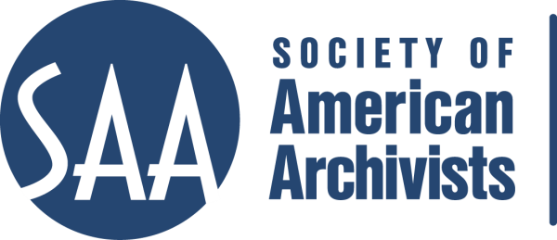
CE Workshop Evaluation Form
Arrangement and Description Track

Workshop Evaluation Form:

Title | EAC-CPF
Reviewer: | James Roth
Directions:
- Quantitative: Each item below begins with a bolded statement. Score each with a 1-5 ranking to indicate your assessment of the veracity of that statement based on your review of workshop overviews/agendas, evaluations, and other materials.
- Qualitative: In the comments section for each item below, please respond to the additional questions posed and any related issues that this workshop raises for you.
- Provide any additional assessments or comments not relevant to one of the specific, numbered areas in the space provided following the table.

Please place an “x” in the appropriate column, use 1=low, undesirable, to 5=high, excellent. |  |  | 1 | 2 | 3 | 4 | 5
1. Does the content appeal to its specified audience? Does it indicate specific categories of archivists and/or levels of expertise to assist potential participants in determining the workshop's relevance for them?  Comments: Yes, this has high appeal. It will catch on in the next few years as early adopters showcase how strong a standard this is. No it does not specify categories of archivists and/or levels of expertise, but it should. This is for the more advanced archivist rather than the beginning archivist. |  |  |  |  |  |  | X
2. To what extent does the subject matter reflect current archival practices and theory commonly accepted in the profession?  Comments: This is a new standard that reflects current/future archival practices and theory. |  |  |  |  |  |  | X
3.. How relevant/appropriate are the teaching and delivery methodologies (lecture, video, PowerPoint, exercises, film, audiotape, discussion, simulation, case study, opportunities for in-course feedback, etc.) to the articulated goals and objectives, and to the content?"  Comments: Lecture, Powerpoint, and discussion/hands-on exercises. Very relevant/appropriate. |  |  |  |  |  |  | X
4. How workable is the time line or agenda for the course? Is there sufficient detail to indicate how the workshop will evolve? Does it allow sufficient time for active engagement between course participants and the instructor(s)?  Comments: This could probably be developed into a two day workshop. Seems like a lot is crammed into the one day. I worry that there isn’t sufficient time to discuss for participants and instructor. |  |  |  |  |  | X
5. To what degree does the list of assigned readings support the content of the proposal?  Comments: No real assigned readings except the standard itself. There are several supporting websites that are highlighted in the powerpoint. This speaks more to the fact that this is a new/emerging standard that has early adopters. |  |  |  |  |  | X
6. Does the presentation support the Learning Outcomes in the descriptions?  Comments: Needs to have learning outcomes in the description—unless you mean Workshop Objective. Those it meets.. |  |  |  |  |  | X
 | A&D Track Considerations
 | 1.Does this content bridge, enhance, and/or build on other workshops (If so, please name) | This is an introductory workshop to the new standard: EAC-CPF. Prerequisite: What is EAC-CPF?
 | 2.Does this build on other workshops not on the list? | Complement to EAD workshops.
 | 3 Should this be part of the A&D Track? | Yes, I believe it should be a part of the A&D track.
 | 4.Where would this workshop fall in the sequence of an A&D track? | It should be similar to EAD. It is a Standards-based workshop, so it should fall somewhere between the truly fundamental A+D courses and the next level up.
 | Why? | Should follow where we place EAD workshops. Should Standards-based workshops be Tactical and Strategic, or Fundamental?
 | 5. What tier does this workshop fall in? (See attached tiers) | Either under Fundamental, or Tactical and Strategic.
 | 6. Target Audience | Practicing Archivists who are considering using EAC.
 | 7. Is the suggested prior “experience/knowledge” appropriate? | I couldn’t find “experience/knowledge” listed. Needs to include.
 | 8. Learning Outcomes:  Are they appropriate and/or relevant? | List of specific, measurable, and actionable outcomes that each person should be able to do (e.g. discuss, explain, evaluate, design) by the end of the course.
 | 9. What should they be?  Please list learning outcomes. | Stated as Workshop Objectives:  - Knowledge of the structure and content of the EAC-CPF standard and the companion content standard ISAAR (CPF);  - Explored the metadata scheme design, including elements and attributes defined to reflect that design: XML techniques used to incorporate data from allied standards and current XML techniques leveraged in the standard;  - Created EAC-CPF record content from existing data structures, such as the Library of Congress Name Authority File, United List of Artists Names, biographical resources, and other related sources;  - and exposure to EAC–CPF projects underway in the United States and internationally.  Need to generate learning outcomes based on Objectives.
 | 10. Can you make suggestions for competencies this workshop would fulfill?
 | 11. Would parts of the content lend themselves to a different format? | Check one: Webinar: - 30 minute - 90minute In person: - 1/2 day - 1 day - X 2 day
 | 12. Which parts? | Consider making this a 2-day workshop
 | 13. Does it lend itself to repurposing as an audio CD? | No.
 | Which parts? | n/a

Other comments:
I think this is an excellent workshop, but the information needs to be put into the new format. Learning outcomes are not listed, target audience could be explained with more detail.

